DOCKER – TASK – 02
================================================================================

- Create a tomcat container on 8080 and deploy sample application in tomcat.

Start Docker Service
- systemctl start docker
- systemctl status docker
- docker images
Shows all images already downloaded on the server.

Download Tomcat Image
- docker pull tomcat
Downloads the latest Tomcat image from Docker Hub.

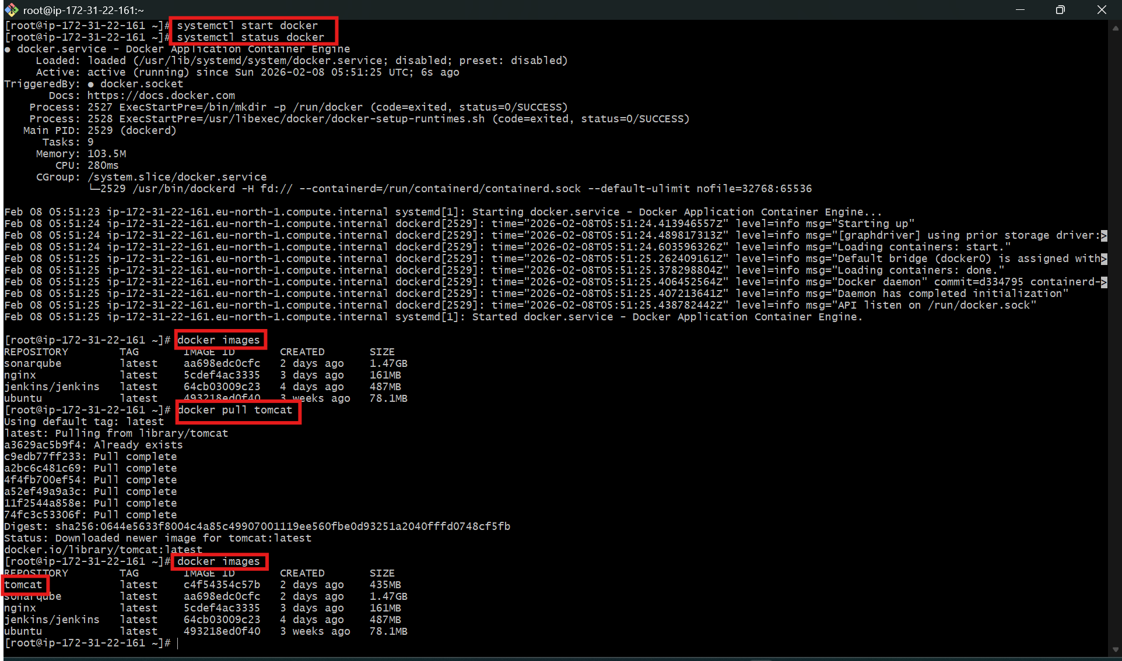
Run Tomcat Container
- docker run -itd -p 8080:8080 tomcat
What happened:
- -i → Interactive
- -t → Terminal
- -d → Run in background
- -p 8080:8080 → Map server port to container port
- tomcat → Image name

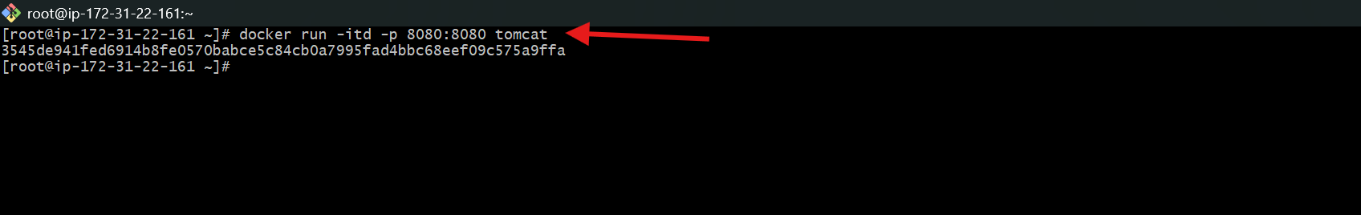
Open Tomcat in Browser
http://13.50.4.207:8080
What happened:
- Browser showed 404 Not Found.
Why?
- Default Tomcat page is disabled.
- No application was deployed yet.

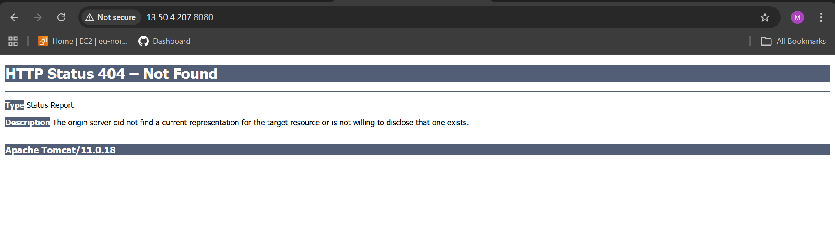
Check Running Containers
- docker ps -a
What happened:
- Shows all containers (running + stopped).

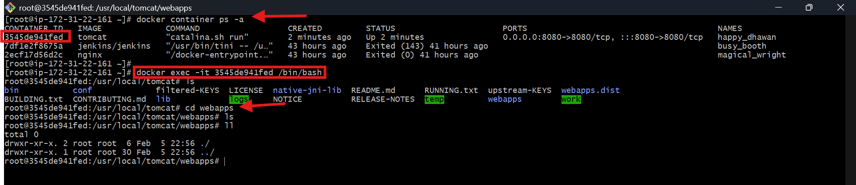

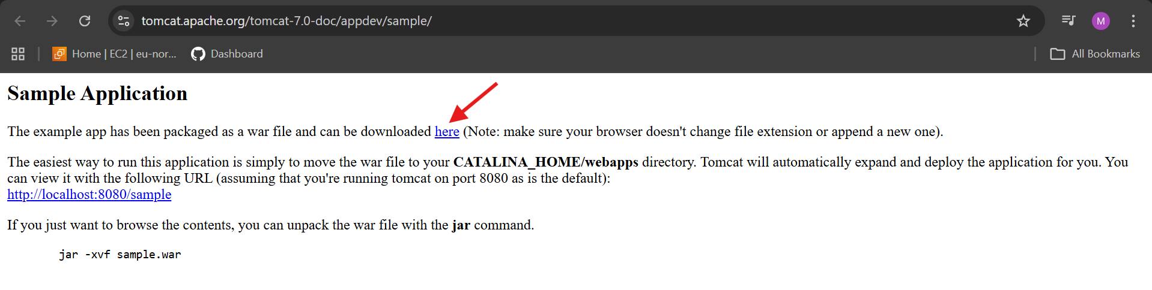
Enter Tomcat Container
- docker exec -it <container_id> /bin/bash
Example:
- docker exec -it 354d9e41fed /bin/bash
What happened:
- Opens terminal inside the container.
Result: Now you are working inside Tomcat.
Go to Webapps Folder
- cd /usr/local/tomcat/webapps
ls
What happened:
- Goes to Tomcat deployment folder.
ls shows files inside.

Update Package List
- apt update
- Updates package information.
Result: System is ready to install software.
Install Wget Tool
- apt install wget -y
- Installs wget (used to download files).
- -y → Auto yes

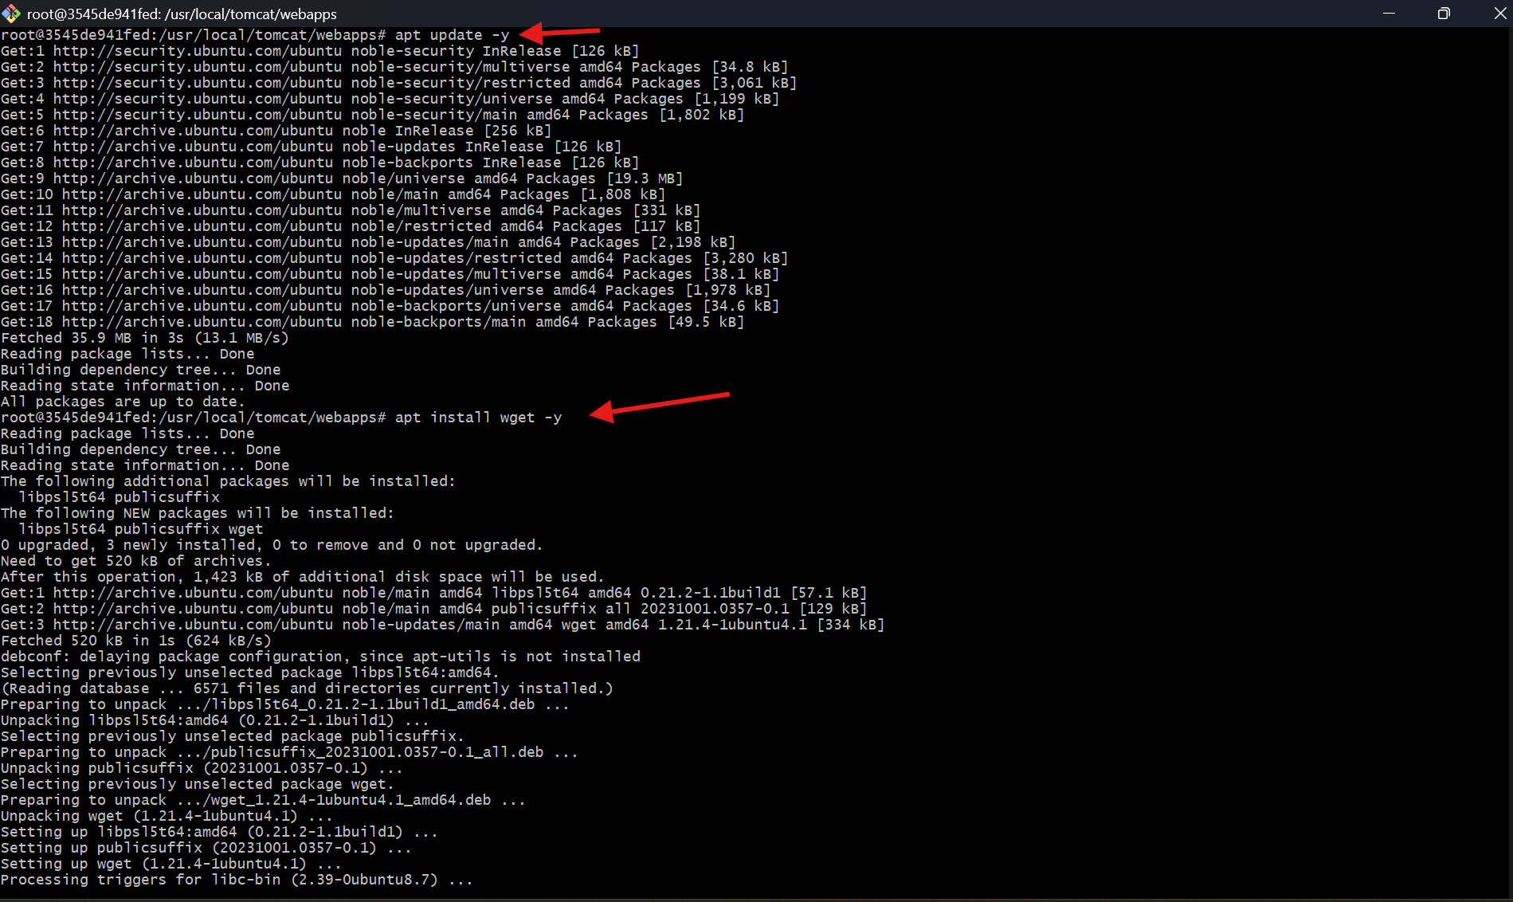
Download Sample App
wget https://tomcat.apache.org/tomcat-7.0-doc/appdev/sample/sample.war
What happened:
- Downloads sample.war file.
- WAR = Java web application.
Result: sample.war saved in webapps folder

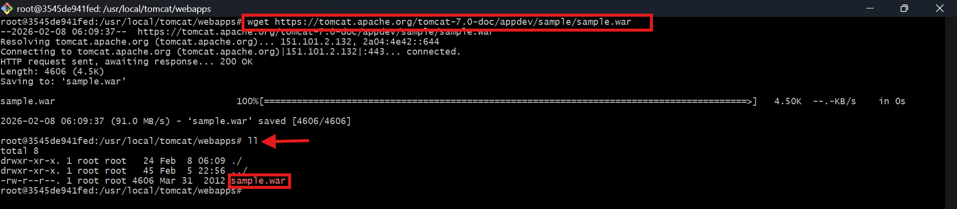
access Sample App in Browser
http://13.50.4.207:8080/sample/
- Browser shows Hello World Sample App.

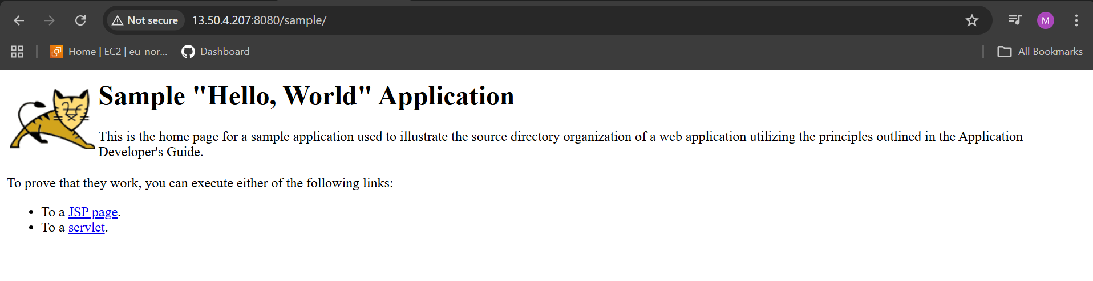

- Create volume and deploy tomcat container on port 8081.

Create a Docker Volume
- docker volume create deploy
What happened:
- Creates a named volume called deploy.
- Docker will store data for this volume permanently
List Docker Volumes
- docker volume ls
Shows all Docker volumes.
Go to Volume Location
- cd /var/lib/docker/volumes
- ls
- Opens Docker’s internal storage folder.
- Shows folders of all volumes

Enter Deploy Volume Folder
- cd deploy/_data

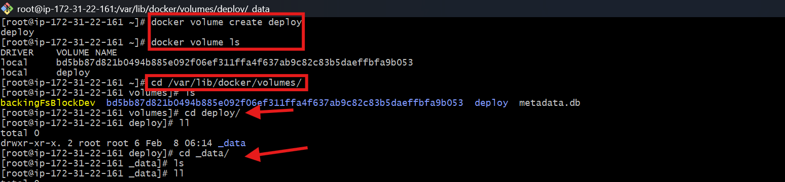
Download Sample App in Volume
wget https://tomcat.apache.org/tomcat-7.0-doc/appdev/sample/sample.war
What happened:
- Downloads sample.war directly into the volume.

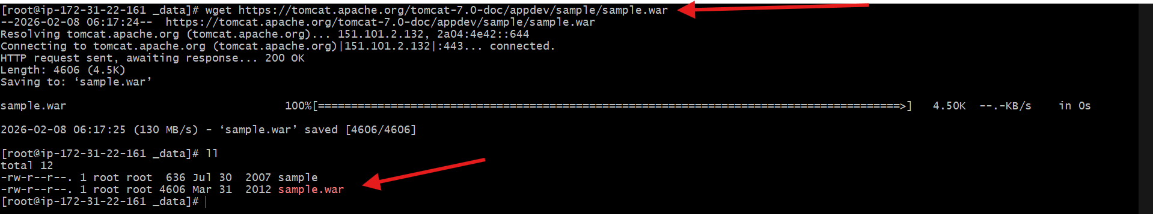
Run Tomcat with Volume Mapping
- docker container run -itd -p 8081:8080 -v /var/lib/docker/volumes/deploy/_data:/usr/local/tomcat/webapps tomcat
What happened:
Part | Meaning
-itd | Run in background
-p 8081:8080 | Host port → Container port
-v ... | Mount volume to Tomcat webapps
tomcat | Image

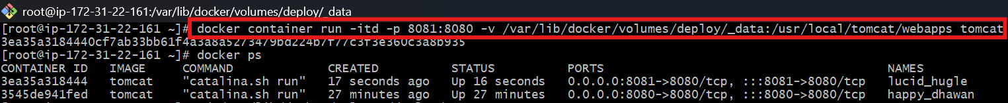
Open App in Browser
http://13.50.4.207:8081/sample
What happened:
- Browser loads app from volume.
- App works without copying files inside container.

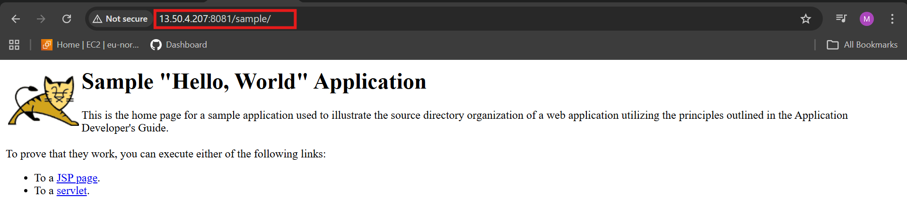

- Limit the nginx container to 500 MB.
Step 1: Run Nginx Container with Memory Limit
- docker container run -itd -p 82:80 --memory 500m nginx
Part | Meaning
docker container run | Create + start container
-i | Interactive
-t | Terminal
-d | Background mode
-p 82:80 | Host port 82 → Container port 80
--memory 500m | Limit RAM to 500 MB
nginx | Image name
Monitor Resource Usage
- docker stats
- Shows live CPU & Memory usage.
Key field:
MEM USAGE / LIMIT → 7.77MiB / 500MiB

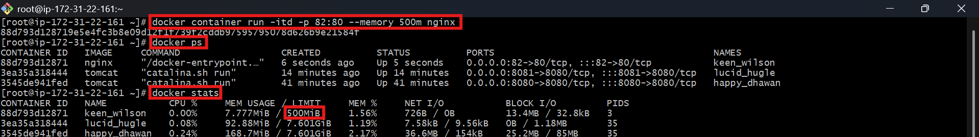
Open Nginx in Browser
http://13.50.4.207:82
Browser accessed container via port 82

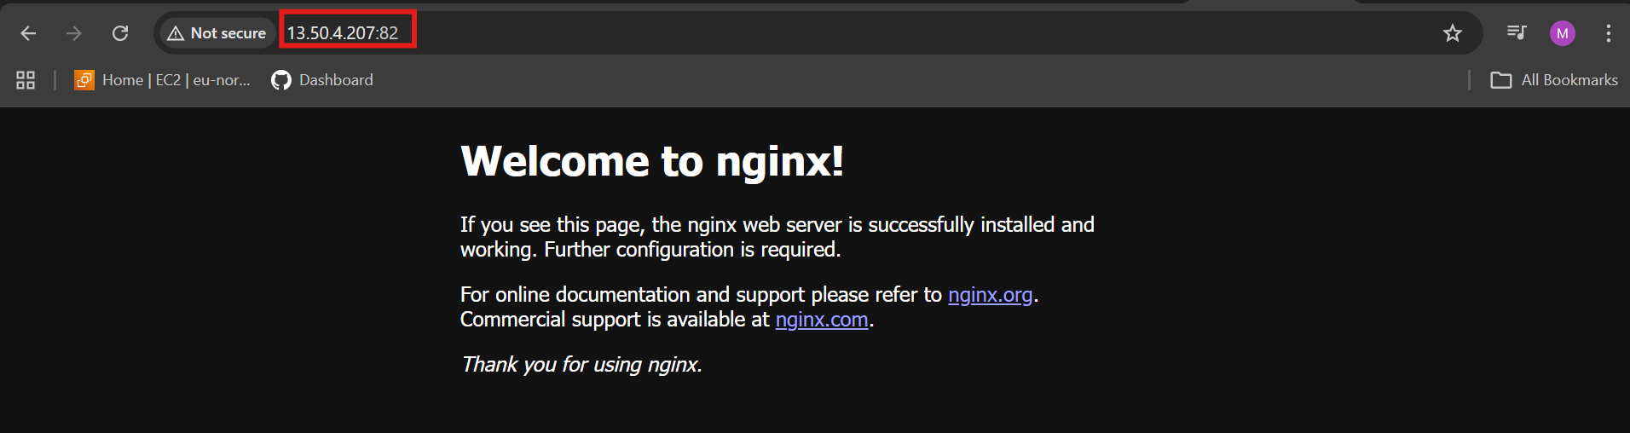

- Create a sample docker file using below instructions.
Base module as amazonlinux:latest
Maintainer your name
Install nginx
COPY one index.html file to image
Expose on port 80
Command to start the nginx container

Create Project Folder
- mkdir nginx-task
- cd nginx-task
Create Custom Web Page (index.html)
vi index.html
File Created: index.html
<html>
<head>
<title>My Docker Nginx</title>
</head>
<body>
<h1>Welcome to Mujju's Docker Nginx Server</h1>
<p>Running on Amazon Linux</p>
</body>
</html>

Create Dockerfile
vi Dockerfile
File Created: Dockerfile
# 1. Base image
FROM amazonlinux:latest

# 2. Maintainer info
LABEL maintainer="mujju"

# 3. Install nginx
RUN yum update -y && \
yum install -y nginx && \
yum clean all

# 4. Copy website file
COPY index.html /usr/share/nginx/html/index.html

# 5. Open port 80
EXPOSE 80

# 6. Start nginx
CMD ["nginx", "-g", "daemon off;"]

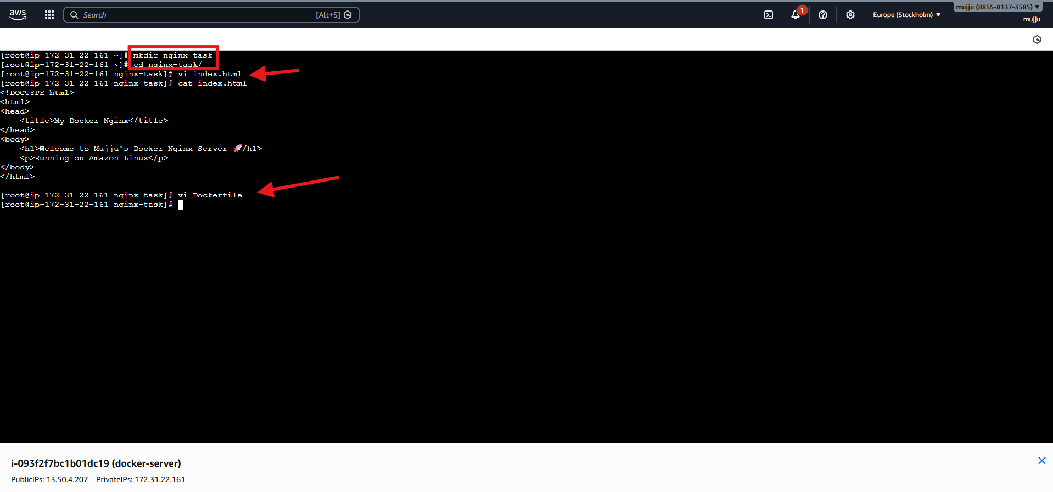
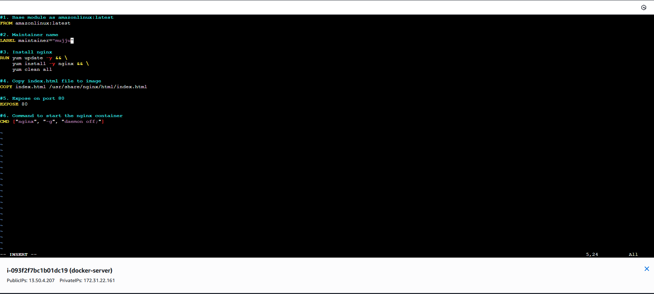
Build Docker Image
- docker build --no-cache -t amazon-nginx .
What happened:
- Builds image using Dockerfile.
- -t amazon-nginx → Image name.
- . → Current folder.

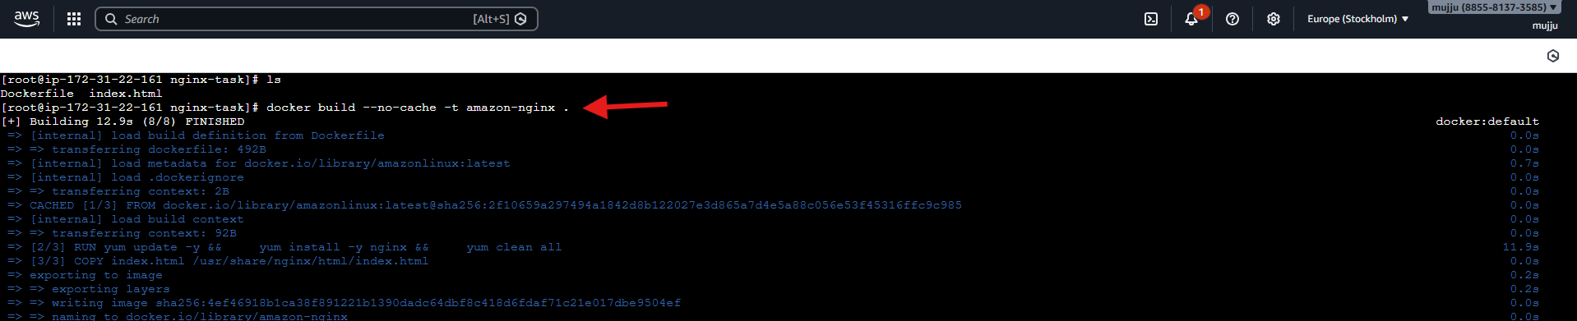
Run Container from Custom Image
- docker run -d -p 9090:80 --name amazon-nginx-app amazon-nginx
What happened:
Part | Meaning
-d | Run in background
-p 9090:80 | Host 9090 → Container 80
--name | Container name
amazon-nginx | Image name

Open in Browser
http://13.50.4.207:9090
What happened:
- Opens your custom website.

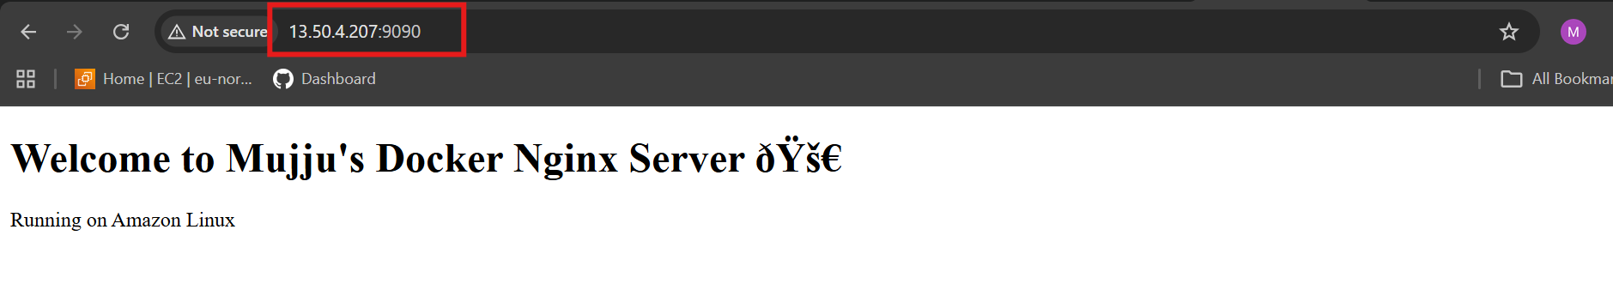

- Push image to Docker hub
Open Docker Hub Dashboard
considered site:
https://hub.docker.com
- logged into Docker Hub.
- Opened Repositories section

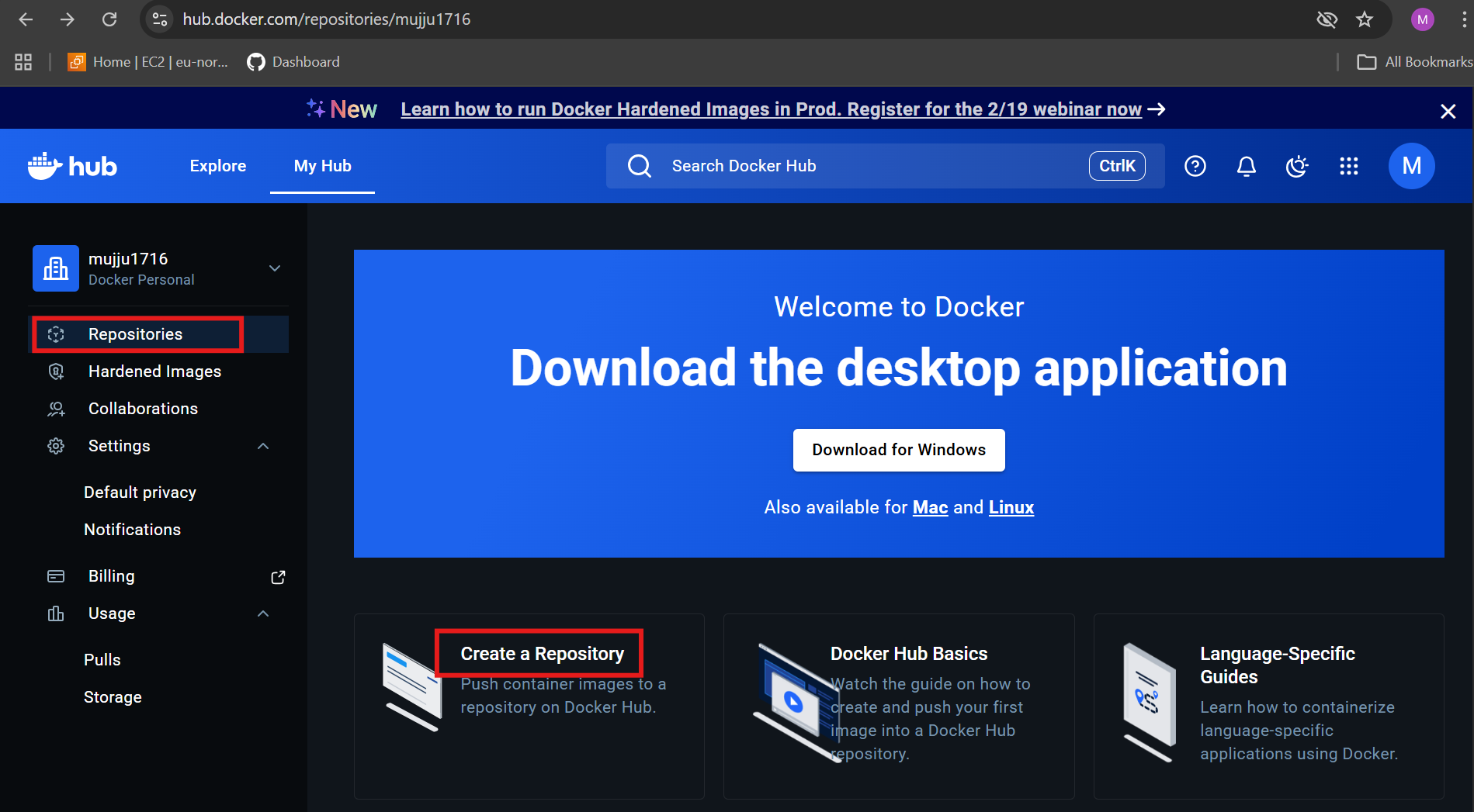
Create a New Repository
On Docker Hub website:
- Click Repositories
- Click Create Repository
- Enter name:
- amazon-nginx
- Select Public
- Click Create
- Created an online storage place for your image.
Result: Repository muju1716/amazon-nginx created.

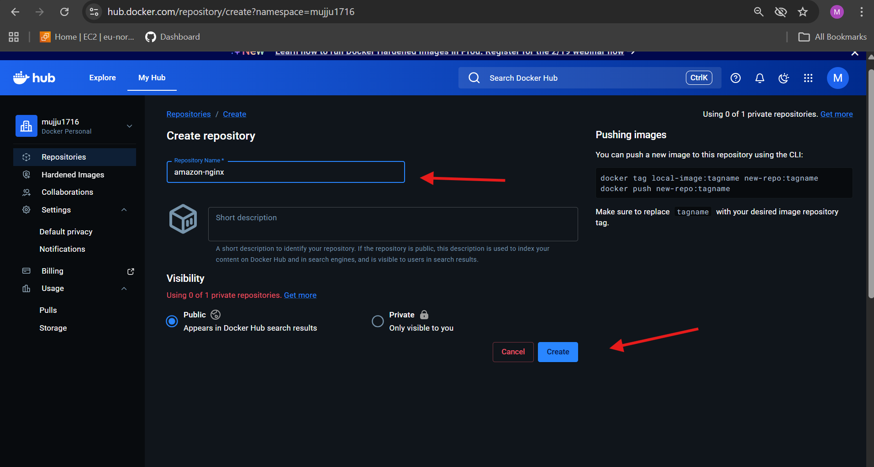
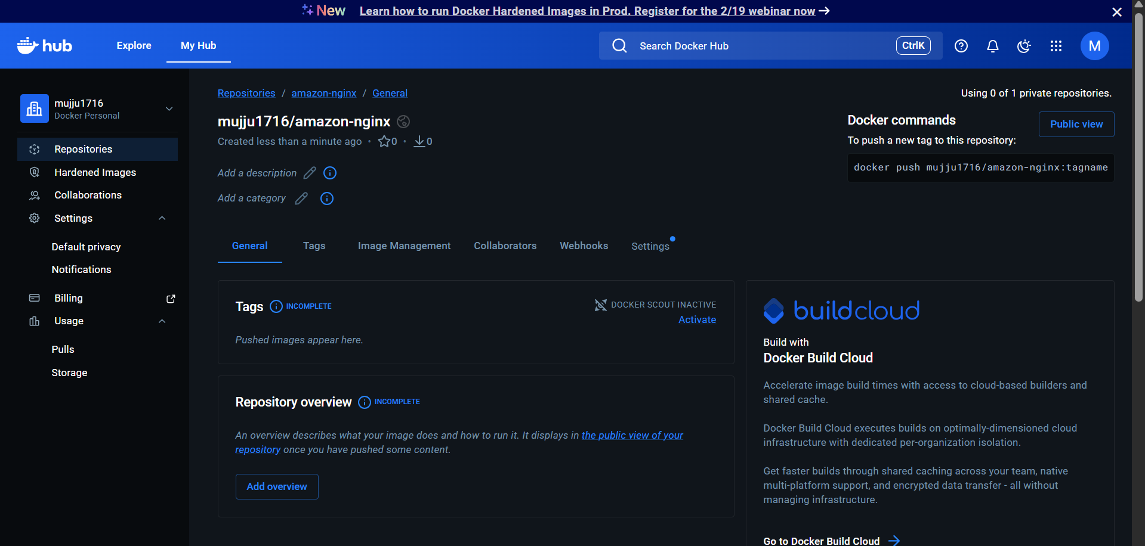
Login to Docker Hub from Server
- docker login
- Connected your EC2 server to Docker Hub.
- Entered username & password

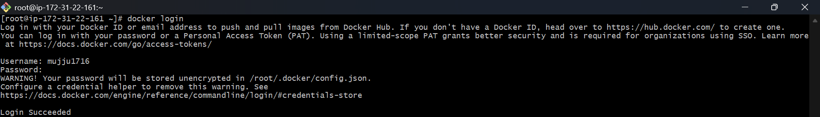
Check Local Images
- docker images
- Listed images on your server.
Result: saw amazon-nginx image.
Tag Image for Docker Hub
- docker tag amazon-nginx muju1716/amazon-nginx
- Renamed image to match Docker Hub format.
Format:
username/repository:tag
Here:
muju1716/amazon-nginx:latest

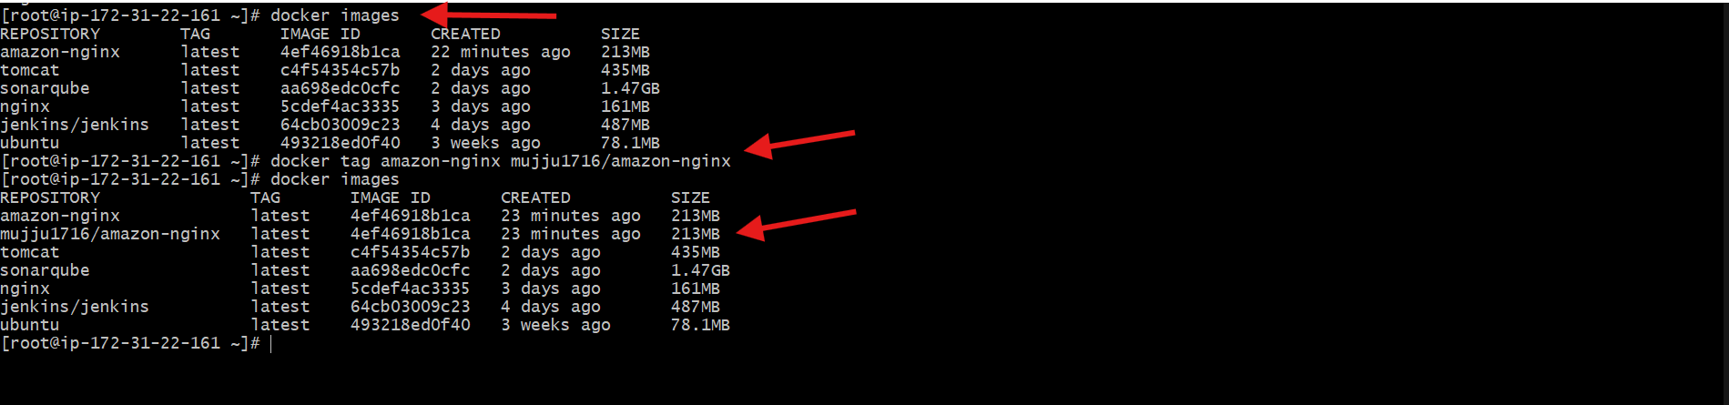
push Image to Docker Hub
- docker push muju1716/amazon-nginx
- Uploaded image to Docker Hub.

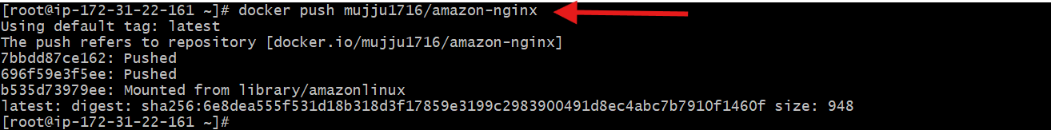
Verify on Docker Hub Website
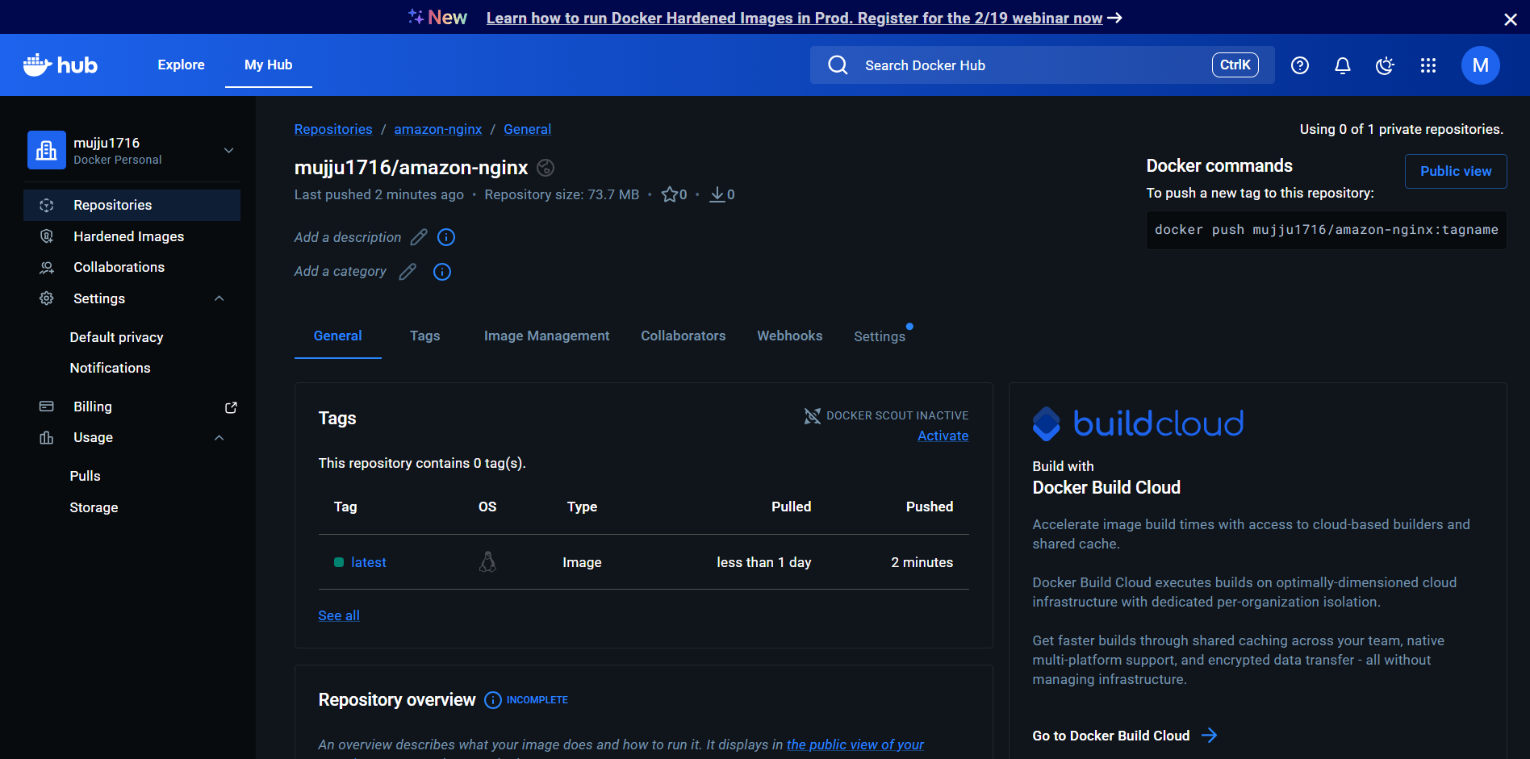

- push image to AWS ECR
- aws configure
Create ECR Repository
- aws ecr create-repository --repository-name amazon-nginx --region eu-north-1
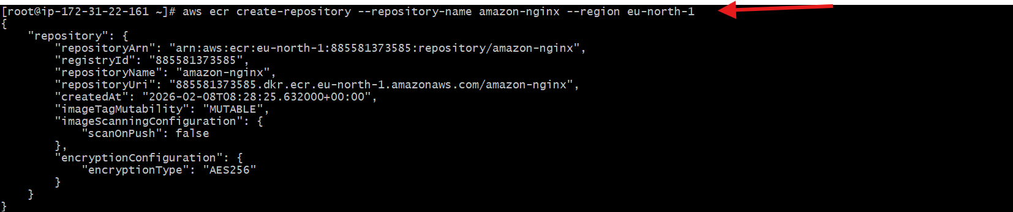
- verified repository is created in aws ecr
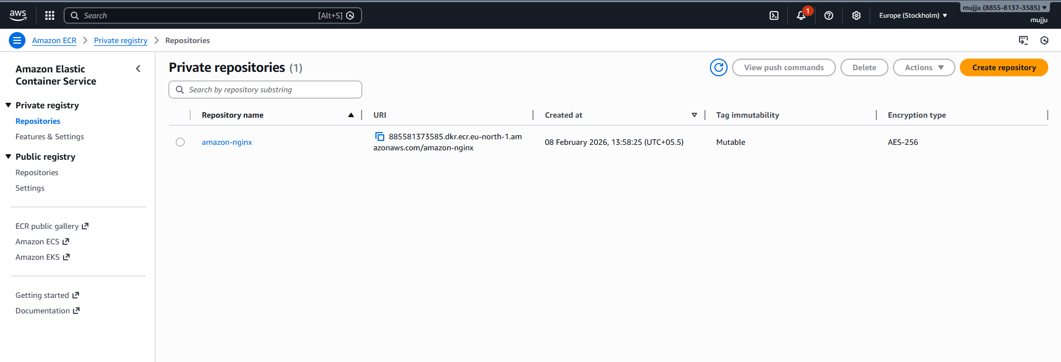
Login to ECR --- Replace ACCOUNT_ID with your AWS account number
- aws ecr get-login-password --region eu-north-1 | docker login --username AWS --password-stdin 885581373585.dkr.ecr.eu-north-1.amazonaws.com
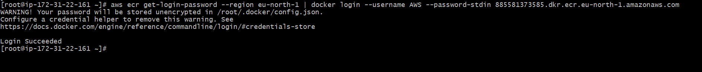
Tag Your Image
- docker tag amazon-nginx:latest 885581373585.dkr.ecr.eu-north-1.amazonaws.com/amazon-nginx:latest
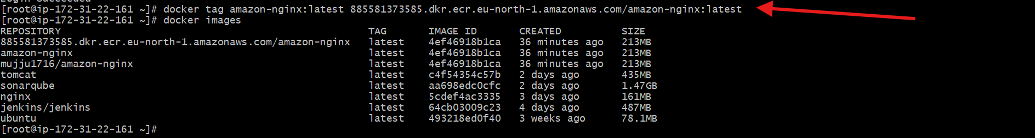

Push Image
- docker push 885581373585.dkr.ecr.eu-north-1.amazonaws.com/amazon-nginx:latest
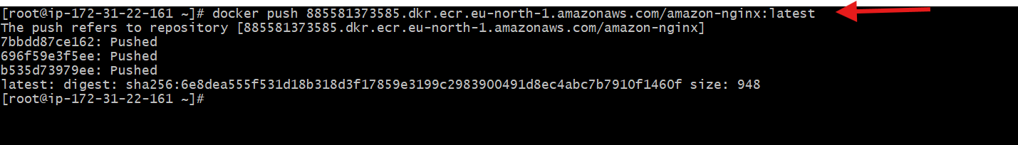
Verified the pushed image by going to aws ecr and image was pushed
